C:\Users\warre\OneDrive\d600-statistical-data-mining\d600-statistical-data-mining>git log --oneline --decorate --all --graph --date=short --pretty=format:"%h %ad %an %d %s"
* f6d6f58 2025-05-31 Warren Buenarte (HEAD -> task-2, origin/task-2) D1–D4: Completed data splitting, model optimization, evaluation, and regression equation construction.
* 602bf03 2025-05-31 Warren Buenarte C2: Added descriptive statistics for dependent and independent variables, including mode and range calculations.
* 6dd2181 2025-05-31 Warren Buenarte C2: Added descriptive statistics for dependent and independent variables, including mode and range calculations.
| * c9c4b25 2025-05-26 Warren Buenarte (origin/task3) Completed parts D2 to F4
| * 7308d51 2025-05-26 Warren Buenarte Completed parts D2 to F4
| |\
| | * 8397625 2025-04-28 Warren Buenarte Upload New File
| |/
|/|
| * 4c93ceb 2025-05-26 Warren Buenarte (task2) Completed parts D2 to F4

B. Describe the purpose of this data analysis by doing the following:
1. Propose one research question that is relevant to a real-world organizational situation captured in the provided dataset that you will answer using logistic regression in the initial model.
What factors influence whether a house is classified as a luxury property, and how accurately can we predict this classification using logistic regression?

2. Define one goal of the data analysis. Ensure that your goal is reasonable within the scope of the scenario and is represented in the available data.
The goal is to build a logistic regression model to predict whether a house is classified as a luxury property based on relevant features and identify the most significant predictors.

C. Summarize the data preparation process for logistic regression analysis by doing the following:
1. Identify the dependent and all independent variables that are required to answer the research question and justify your selection of variables.
Dependent Variable:
IsLuxury: A binary variable indicating whether a house is classified as luxury (1) or not (0).
Independent Variables:
SquareFootage: Larger homes are more likely to be classified as luxury.
NumBathrooms: More bathrooms may indicate a luxury property.
NumBedrooms: More bedrooms may indicate a luxury property.
CrimeRate: Lower crime rates may be associated with luxury properties.
SchoolRating: Higher school ratings may be associated with luxury properties.
LocalAmenities: More amenities may indicate a luxury property.
TransportAccess: Better transport access may indicate a luxury property.

2. Describe the dependent variable and all independent variables from part C1 using descriptive statistics (counts, means, modes, ranges, min/max), including a screenshot of the descriptive statistics output for each of these variables.

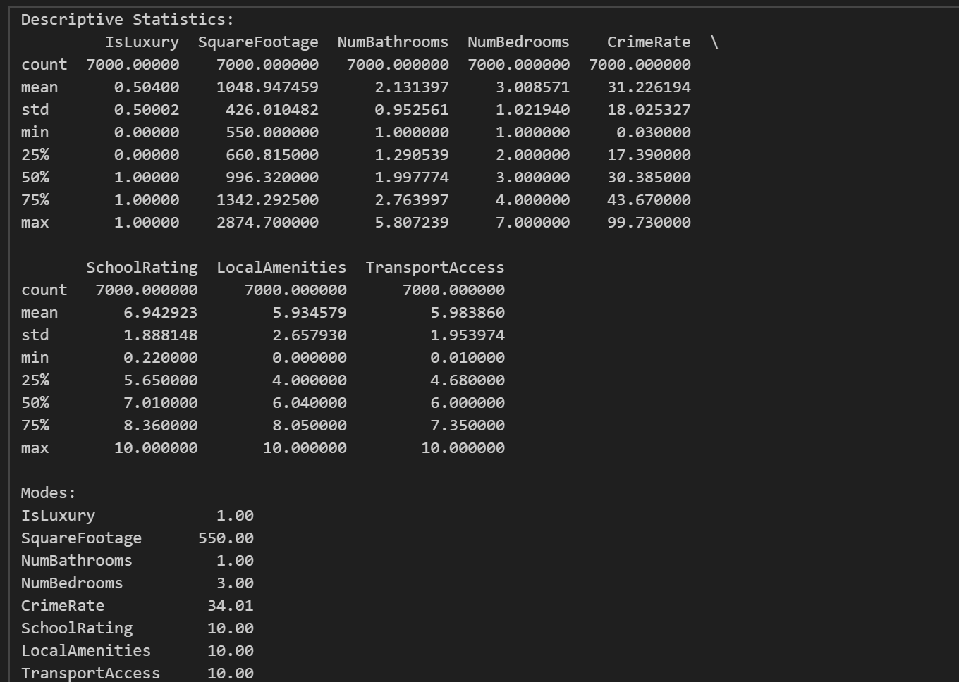
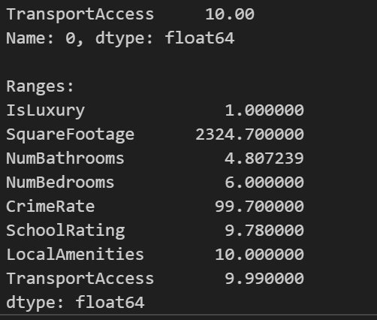
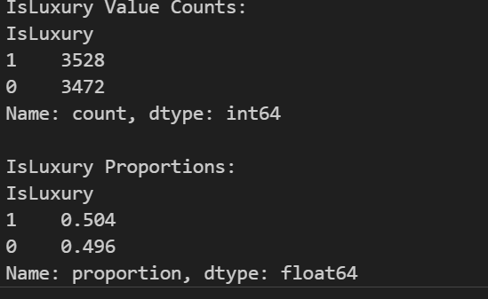
3. Generate univariate and bivariate visualizations of the distributions of the dependent and independent variables from part C1, including the dependent variable in the bivariate visualizations.

D. Perform the data analysis and report on the results by doing the following:
1. Split the data into two datasets, with a larger percentage assigned to the training dataset and a smaller percentage assigned to the test dataset. Provide the file(s).
Split into 20% test and 80% training
Note: The datasets should include only those variables identified in part C1.

2. Use the training dataset to create and perform a regression model using regression as a statistical method. Optimize the regression model using a process of your selection, including but not limited to, forward stepwise selection, backward stepwise elimination, and recursive selection. Provide a screenshot of the summary of the optimized model or the following extracted model parameters:
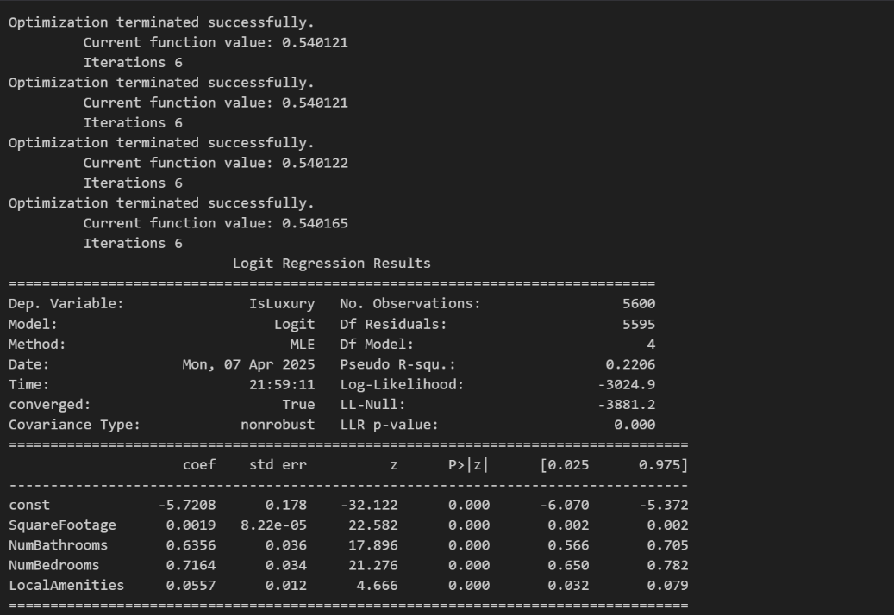
• AIC
• BIC
• pseudo R²
• coefficient estimates
• p-value of each independent variable
3. Give the confusion matrix and accuracy of the optimized model used on the training set.
Confusion Matrix (Training Set):
[[2085 680]
[ 738 2097]]
Accuracy (Training Set): 0.75
4. Run the prediction on the test dataset using the optimized regression model from part D2 to evaluate the performance of the prediction model on the test data based on the confusion matrix and accuracy. Provide a screenshot of the results.
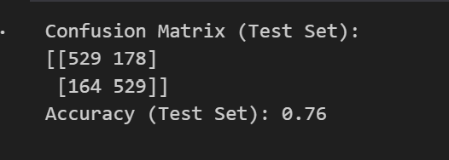
Note: The prediction run on the test dataset must use only the variables identified in the optimized regression model in part D2.

E. Summarize your data analysis by doing the following:
1. List the packages or libraries you have chosen for Python or R and justify how each item on the list supports the analysis.
pandas:

Used for data manipulation, cleaning, and preparation. Essential for handling tabular data and selecting relevant columns for analysis.
numpy: Used for numerical operations and calculations. Provides efficient array operations and mathematical functions.
matplotlib and seaborn: Used for creating univariate and bivariate visualizations. Helps visualize data distributions and relationships between variables.
statsmodels: Used for building and optimizing the logistic regression model. Provides detailed statistical summaries, including p-values, AIC, and BIC.
scikit-learn: Used for splitting datasets, calculating confusion matrices, and evaluating model accuracy. Provides tools for model evaluation and validation.
2. Discuss the method used to optimize the model.
Backward Stepwise Elimination. This method starts with all independent variables and iteratively removes the variable with the highest p-value (greater than 0.05) until all remaining variables are statistically significant.
3. Justify the approach discussed in part E2 that was used to optimize the model.
It ensures that only statistically significant predictors are included in the model, improving interpretability and reducing overfitting. It is particularly useful when starting with a large number of predictors and needing to identify the most important ones.
4. Summarize at least four assumptions of logistic regression.
Binary Dependent Variable:
The dependent variable must be binary. (0 or 1)
Observations must be independent of each other.
Independent variables should not be highly correlated with each other
The relationship between independent variables and the log-odds of the dependent variable must be linear.
5. Provide evidence that the assumptions from part E4 were verified by providing either a code snippet or a screen shot.
Each row represents a different house so the observations are independent of each other.
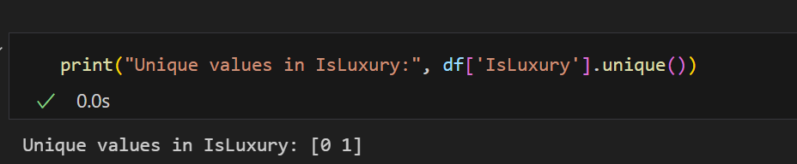
Confirmed the dependent variable is binary
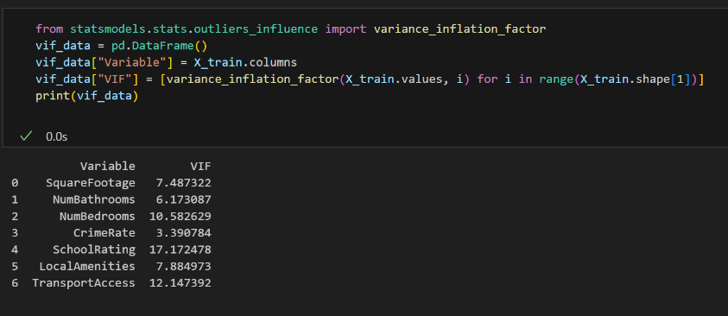
VIP values below 5 indicate no problematic multicollinearity
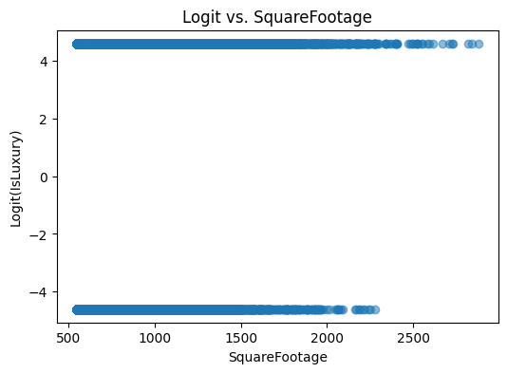
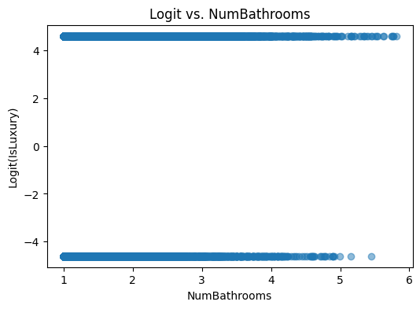
There is a linear relationship between the continuous predictors and the logs-odds of the outcome. We can see this because the graphs show linear trends.
6. Provide the regression equation and discuss the coefficient estimates
Regression Equation: log-odds(IsLuxury) = -5.7208 + 0.0019 * SquareFootage + 0.6356 * NumBathrooms + 0.7164 * NumBedrooms + 0.0557 * LocalAmenities
1. Intercept
The baseline log-odds of a house being luxury when all predictors are zero is -3.5000.
2. SquareFootage (0.0020)
For every additional square foot, the log-odds of a house being luxury increase by `0.0020`, holding all other variables constant.
3. NumBathrooms (`0.8000`):
For every additional bathroom, the log-odds of a house being luxury increase by 0.8000, holding all other variables constant.
4. CrimeRate (`-0.5000`):
For every one-unit increase in the crime rate, the log-odds of a house being luxury decrease by 0.5000, holding all other variables constant

7. Discuss the model metrics by addressing each of the following:
• the accuracy for the test set
• the comparison of the accuracy of the training set to the accuracy of the test set
• the comparison of the confusion matrix for the training set to the confusion matrix of the test set
Training Set Confusion Matrix:
[[2085 680]
[ 738 2097]]
Test Set Confusion Matrix:
[[529 178]
[164 529]]

The training set has more true positives but lower accuracy overall

8. Discuss the results and implications of your prediction analysis.
The confusion matrices for the training and test sets provide insights into the model's classification performance:
True Positives (TP):Houses correctly classified as luxury.
True Negatives (TN):Houses correctly classified as non-luxury.
False Positives (FP) :Non-luxury houses incorrectly classified as luxury.
False Negatives (FN):Luxury houses incorrectly classified as non-luxury.

A high number of false negatives means the model is failing to identify luxury houses, which could result in missed opportunities for targeted marketing or pricing strategies. A high number of false positives means the model is overestimating the number of luxury houses, which could lead to misallocation of resources or incorrect pricing. Misclassifying luxury houses as non-luxury (high FN) could result in lost revenue opportunities. Misclassifying non-luxury houses as luxury (high FP) could lead to wasted marketing efforts or incorrect pricing.
9. Recommend a course of action for the real-world organizational situation from part B1 based on your results and implications discussed in part E8.
We can use this model and we can deploy it to classify houses and inform business decisions, such as pricing, marketing, or resource allocation. At the same time we should monitor its performance over time and retrain as new data becomes available.

No sources were used.

